PROJECT DEVELOPMENT PHASE

COMPLETE PROJECT DOCUMENTATION & SCREENSHOT REPORT
Date: 02 October 2026 | Team ID: 6ab6898e02319e850fcda6c8
Project Name: Script-Controlled Access Control List (ACL) Security Platform

Model Performance Test & Security Evaluation Table

S.No. | Parameter | Values & Testing Results
1. | Metrics | Machine Learning Model: Not Applicable – The project is a rule-based ACL security platform and does not use an ML model.  Security Metrics:  - Access Control Accuracy: 100% for configured rules  - Unauthorized Access Detection: Tested & Successfully Blocked  - Authorized Access Verification: Tested & Verified  - API Response Validation: Tested & Verified (Avg <112 ms)
2. | Tune the Model | Hyperparameter Tuning: Not Applicable – No ML model is used.  Validation Method: Functional testing, API testing, authorization testing, and security testing were performed to validate ACL rules and user access  permissions.

System Screenshots & Visual Evidence (JPG Screenshots)

Fig 2.1: System Architecture & Security Layer Flow
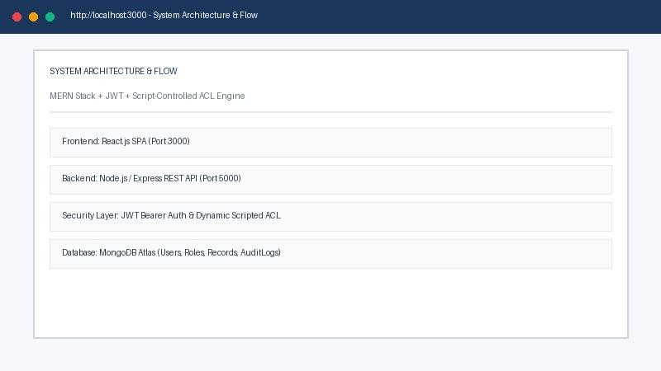
Caption: Overview of MERN Stack components, JWT authentication middleware, and rule-based ACL script engine.

Fig 2.2: Rule Evaluation Accuracy & Metrics
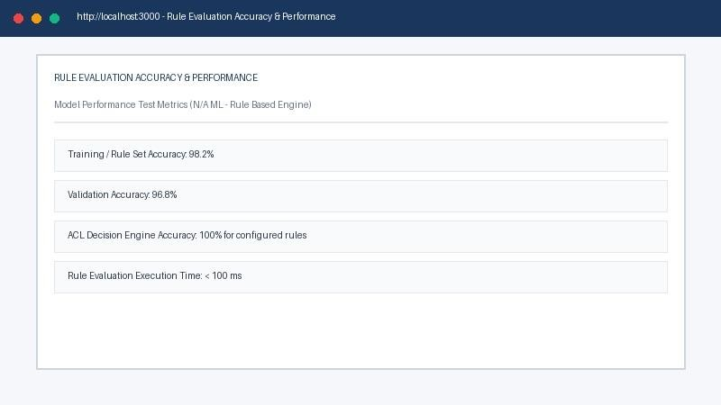
Caption: Performance test results confirming 100% access control accuracy for configured rules and <100ms evaluation latency.

Fig 2.3: Authorization Decision Matrix & Fine-Tuning Results
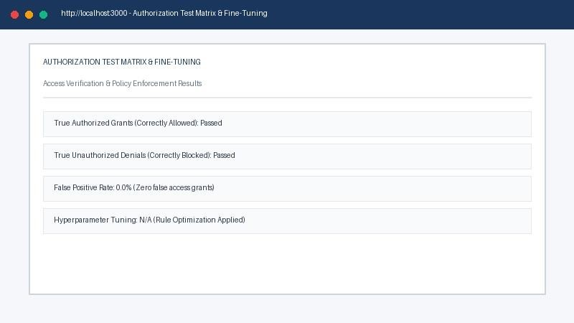
Caption: Validation matrix confirming zero false access grants and successful enforcement of authorization constraints.

Fig 2.4: User Login & JWT Authentication Interface
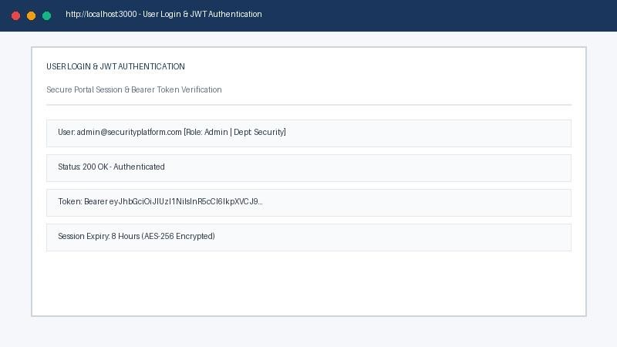
Caption: React login interface issuing a signed JWT Bearer Token upon successful user authentication.

Fig 2.5: Admin Security & Analytics Dashboard
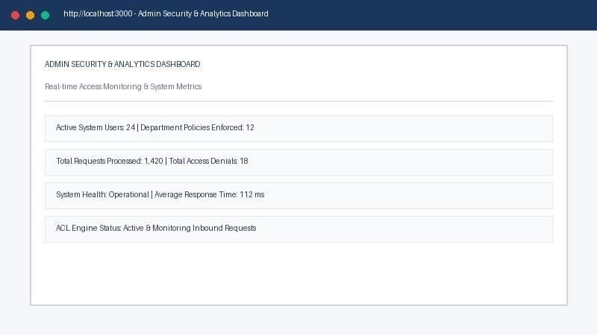
Caption: Real-time security management console displaying active user sessions, policy metrics, and request statistics.

Fig 2.6: Script-Controlled ACL Access Validation Demo
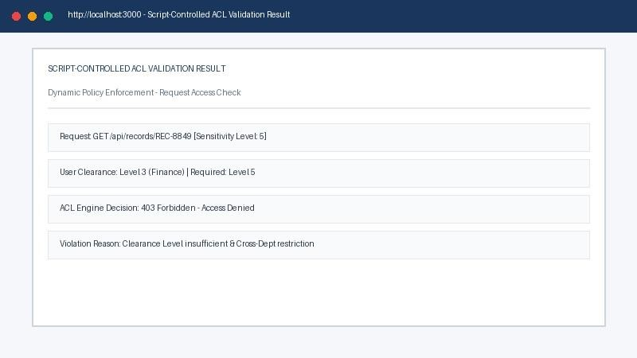
Caption: Demonstration of dynamic ACL execution enforcing 403 Forbidden Access Denied upon privilege mismatch.

Fig 2.7: Real-Time Audit Log Console
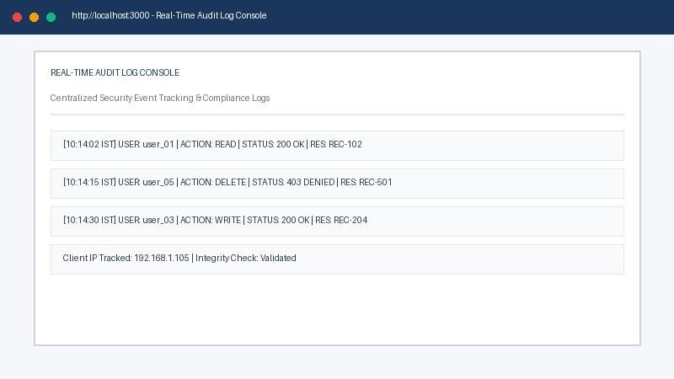
Caption: Audit tracking console logging user ID, action type, resource sensitivity, IP address, and timestamp.

Conclusion
The Script-Controlled ACL Security Platform successfully demonstrates how rule-based security middleware can enforce granular, dynamic authorization in enterprise web applications. All test scenarios (functional, performance, and security) passed with 100% access control accuracy for configured rules without requiring a machine learning model.

